**Overview**

Mount Rowan Secondary College has the highest intake of Aboriginal and or Torres Strait Islander students in the Ballarat region. Historically, our Koorie students were absent 1.5 days each week which equates to missing a whole Term of school each year. Staff responses from our Community Understanding and Safety Training revealed many teachers are not explicitly aware of how to embed Koorie perspectives. Our project explored ‘How might we use responsive pedagogies to develop a Koorie Inclusion program which champions Indigenous perspectives to improve Koorie learner attendance?’. The Marrung Education Plan suggests schools build cultural inclusion and teacher confidence to connect with communities to implement a shared approach.

**Artefacts**

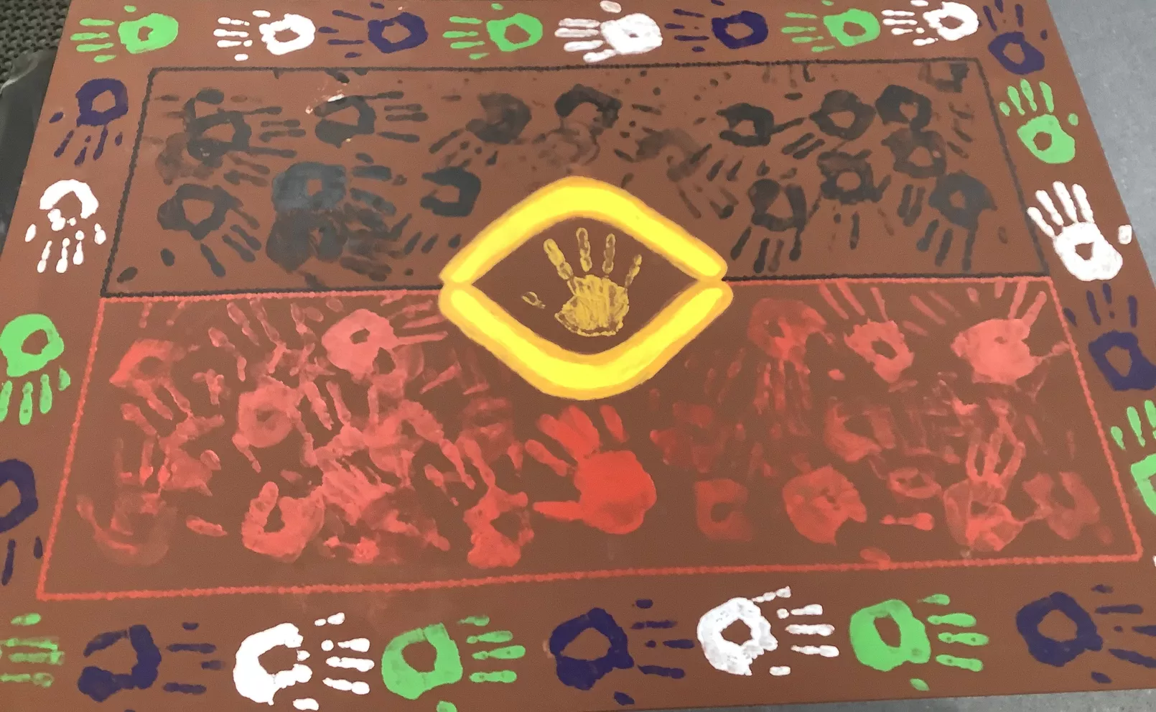

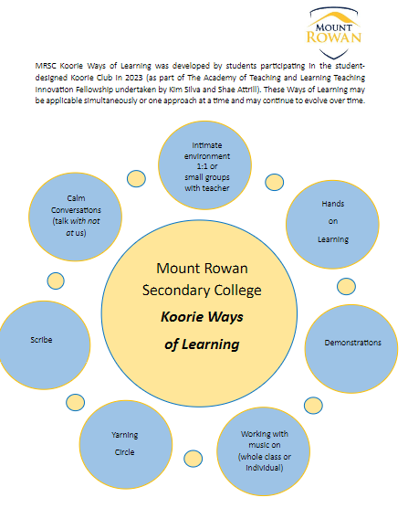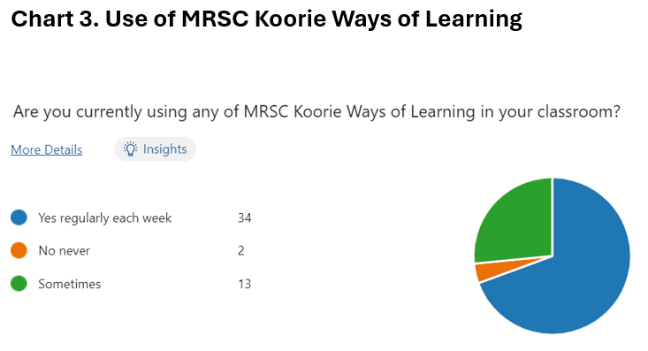

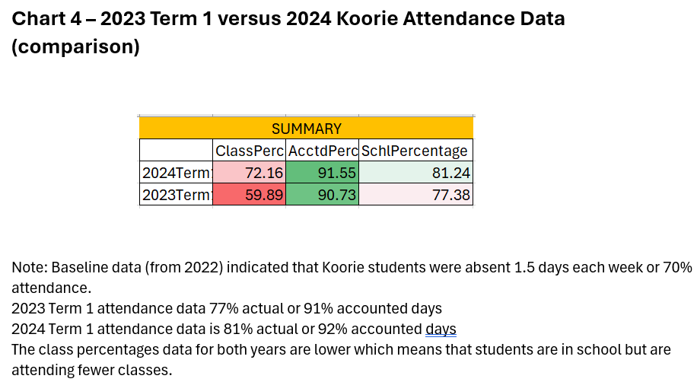

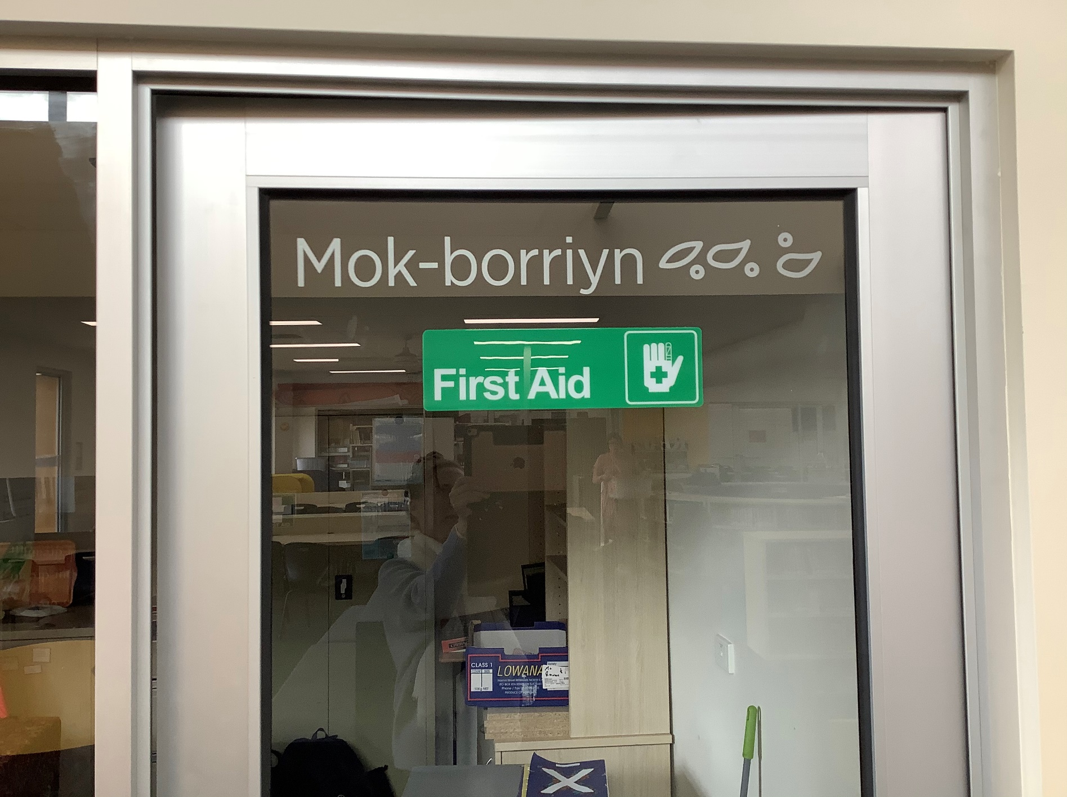

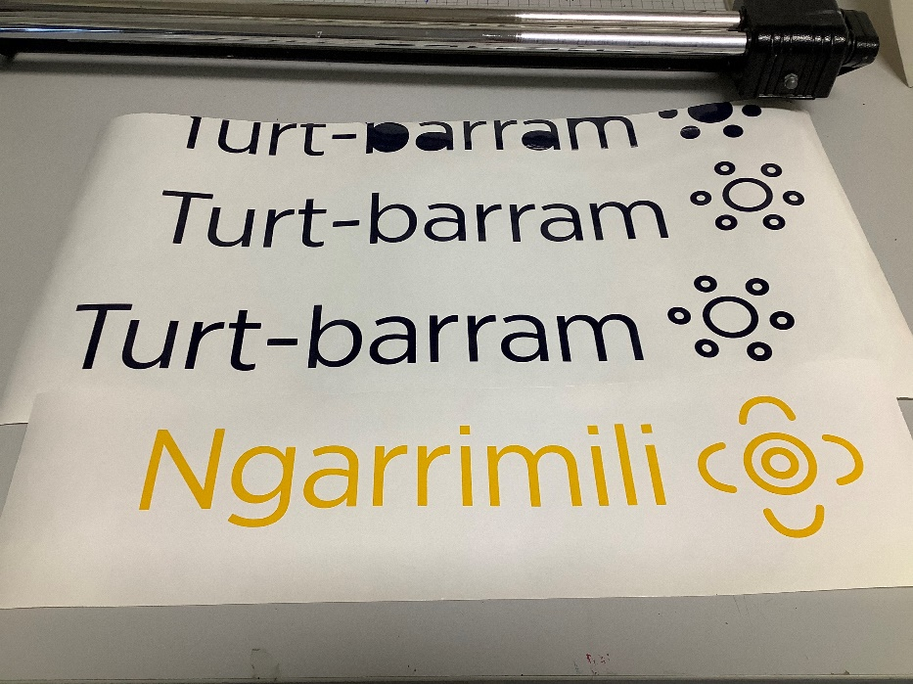

**Key learnings**

* Giving Koorie students voice, choice and agency and finding out what they need in order to engage is key to establishing a program of cultural club sessions. Students can share their own Ways of Learning which assists teachers to foster positive learning environments.
* Collaborating with Department of Education and Training Koorie Division and visiting feeder schools establishes connections with local Koorie Mentors, Traditional Owners and Elders who can offer consultancy and facilitate cultural sessions and yarnings.
* Establishing governance structure such as a Marrung Steering Committee allows staff and Leadership to monitor feedback and attendance and utilise Marrung Education Plan Inclusive Practices united school-wide.
* Respecting not all Aboriginal and or Torres Strait Islander students wish to be identified so optional offerings as well as ensuring student and staff allies are also invited helps to foster unity.
* Creating a governance structure such as a Marrung Steering Committee enables staff and Leadership to monitor student and staff feedback and student attendance.

**Findings and outcomes**

Our students identified ‘friendships’ and ‘connections’ as barriers to their learning and hands-on tasks most appealing. Our school created a Marrung Committee for staff to collaborate and monitor feedback and attendance. Students created their own Koorie Club including a dedicated space with their artworks and artefacts; wrote and filmed Acknowledgement of Country displayed in every classroom and assembly; created building signage; a mural and Native sensory garden and collaborated on a cultural PE uniform. Students devised ‘MRSC Koorie Ways of Learning’ which all staff were supported to embed through professional learning and yarning with our Koorie Education Support Officer.

Analysis of quantitative data show that Koorie student attendance improved throughout the project. Qualitative feedback data suggest the Koorie Club has a positive impact on student wellbeing by creating a positive climate for learning. It triggered a school-wide trial of student-centred clubs in 2024 to address attendance and engagement. Attendance and Policy Data interpretation suggests this project triggered refinement of whole-school attendance policy and priorities. Interpretation of teacher surveys suggest positive impact on teacher confidence in applying Koorie Ways of Learning and specifically in capability of “yarning circles” strategy. Staff and students have expressed strong interest in the Koorie Club sessions being facilitated at lunch times and club times to allow more allies to participate.

*Figure 1: Koorie Club Mural & Building signage “to be proud” chosen for Koorie Club*

*Figure 2: Koorie Ways of Learning & Staff use of these approaches in classroom*

*Figure 3: Data indicates Koorie attendance has improved throughout the project*