***Character-driven Narratives***

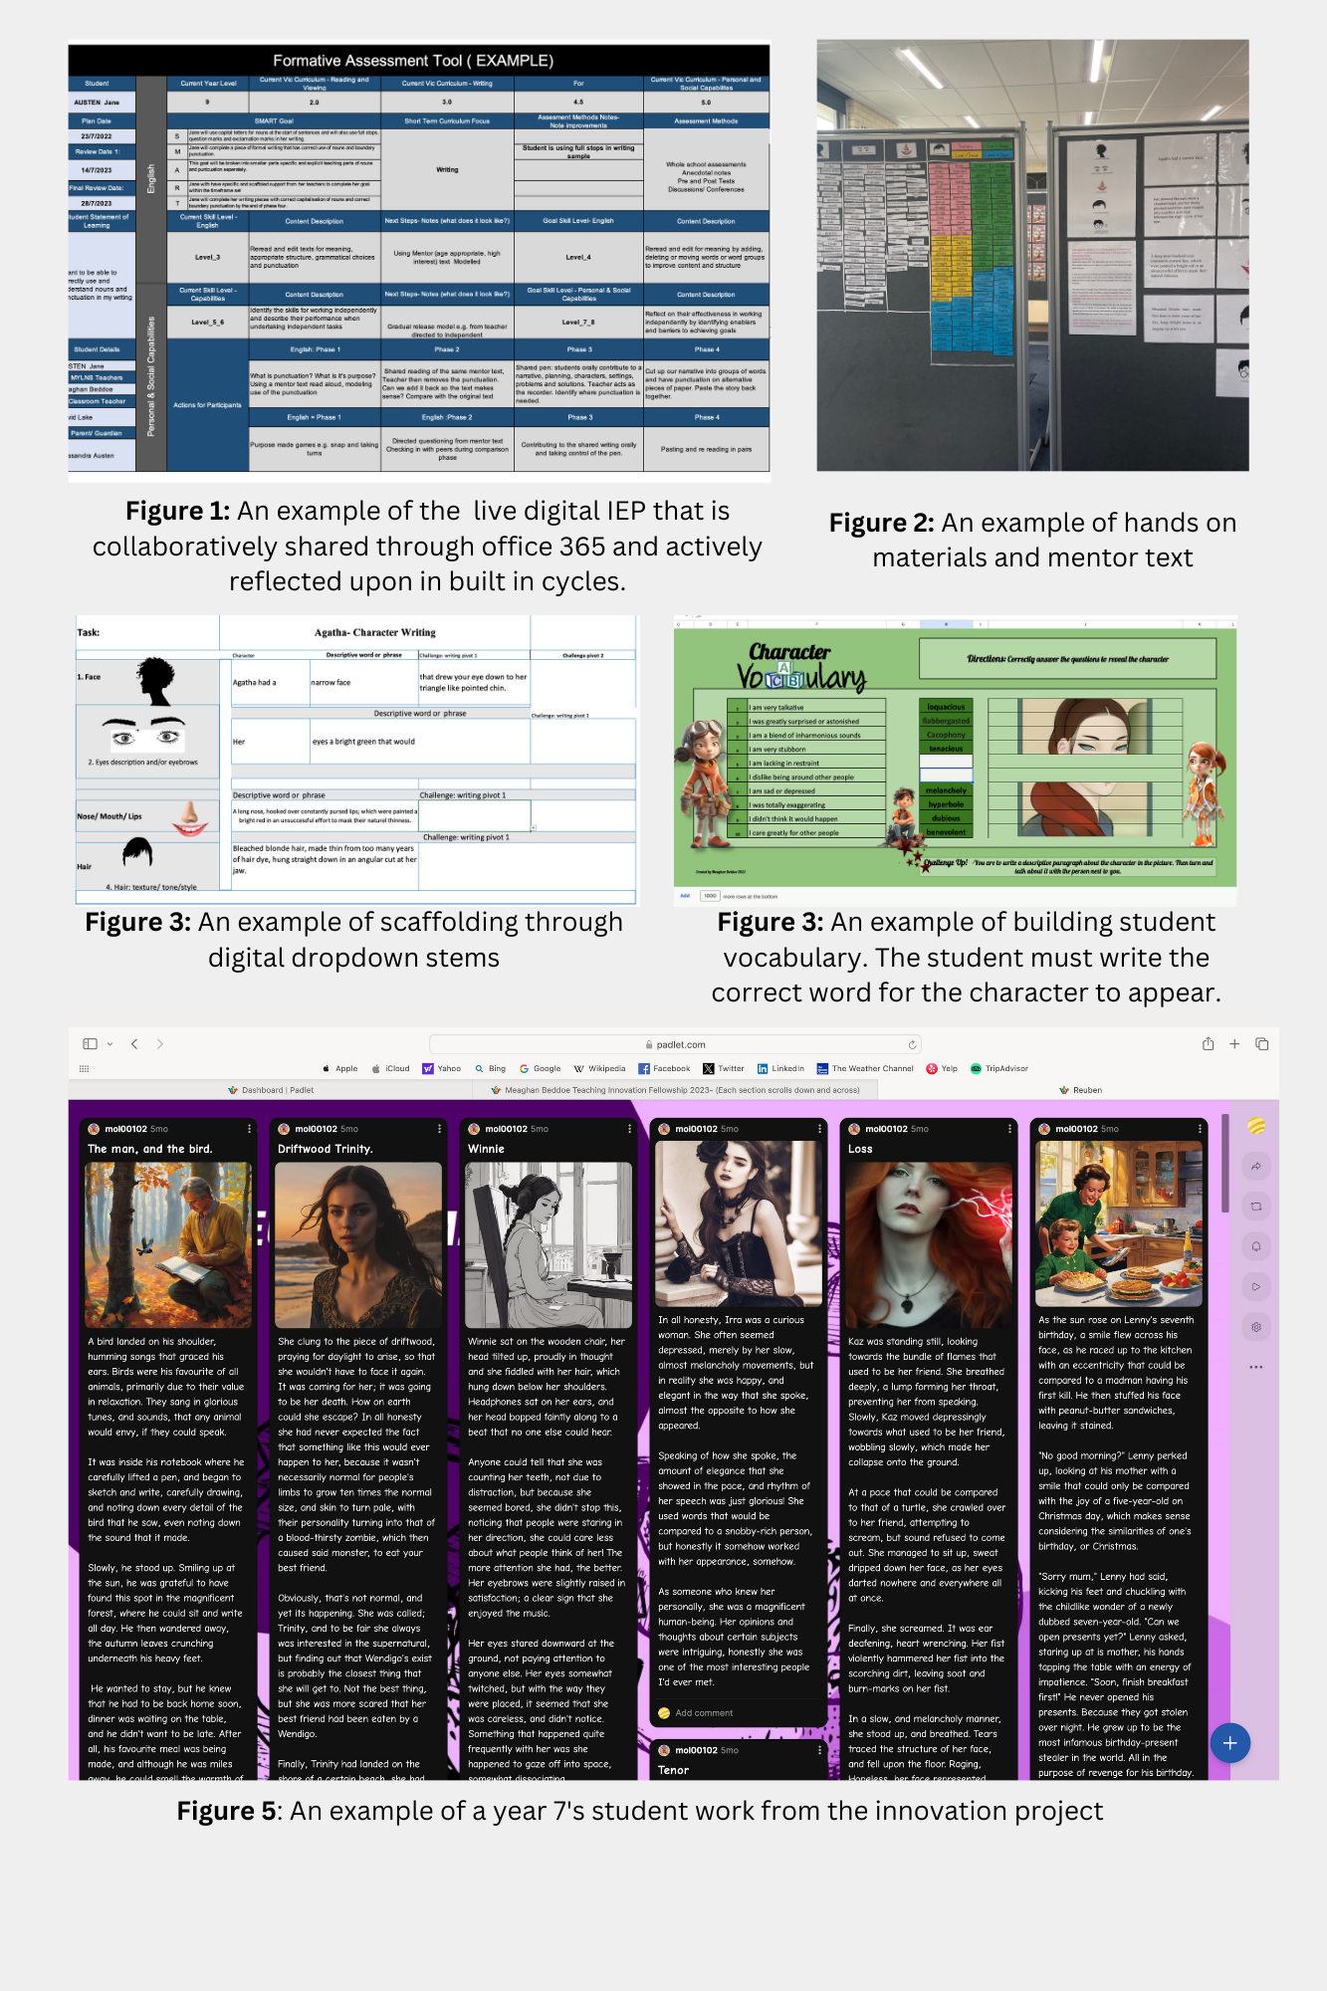

**Overview**

As a team, we identified that our year seven and nine students were not demonstrating the growth and skills required in writing through our data investigations. We posed the following questions:

* How can we inspire students to overcome challenges, discomfort, and self-perception as non-writers?
* How can we help students see the power of making mistakes in writing as normal?
* How can we reshape the narrative writing process to improve and engage students in writing?

We decided to trial character-driven narrative writing and differentiation, starting with the research “The Impact of COVID-19 on Teaching in Australia - A Literature Synthesis.”

**Key learnings**

Firstly, it was key for us to recognise post-pandemic why our students, from a range of learning levels, were not engaging in the writing process and not perceiving themselves as writers. For our secondary school students, we found that they considered the traditional linear narrative story mapping to be disengaging and lacking in structure and depth to support them as writers. Secondly, we considered carefully how we would track learning goals and student growth. We used a live digital formative assessment IEP tool to track short and long-term goals that were created and shared between the student, teacher, and parent. All were aligned to the curriculum, scaffolded, and differentiated, with check-in cycles to allow for reflection of skill development. Lastly, choosing an AI to underpin and support the approach PADLET was chosen as is DET-approved and versatile teaching tool that can enhance student engagement, critical thinking, comprehension, collaboration, and assessment.

**Findings and outcomes**

Student feedback revealed that writing character-driven narratives gave them a strong sense of ownership over their work. This process helped them view themselves as writers leading to increased motivation and engagement. Students noted even small changes in a character's physical appearance or actions could significantly impact their interactions and reactions within the narrative world and in the visual representation of their writing. Having short- and long-term live digital IEP goals provided teachers with built-in reflective learning time and practice. This allowed them to discuss and adjust learning for students' varying needs.

The unexpected highlight of character-driven narratives was that they provided students with a unique opportunity to practice dialogue, description, and action. This approach is often more engaging and accessible than focusing on concepts like punctuation and dialogue through the setting. Students improved their writing by using descriptive language, vivid imagery, and figurative language to make their narratives engaging. This process revealed that students often revise and refine their work to align with their vision. They underwent multiple drafts and revisions to improve clarity, structure, and emotional impact. Choosing the right words and sentences was crucial for the AI to convey their personal vision effectively. This small-scale trial will be rolled out in the school later in 2024.

*Creating documents that scaffolded our students’ success was key. This was achieved by looking at what our data was telling us and creating authentic evidence-informed resources that suited our context. (Some examples are shown above)*