Deepen your knowledge of student engagement
The following links contain a range of ideas to support you and your school in developing student engagement.
These resources have been curated following the Teaching Excellence Program Alumni event: Addressing and understanding dysregulated behaviour panel discussion held on 4 July 2024 at the Victorian Academy of Teaching and Leadership.

Ideas for using these resources
- Professional Learning: Sign up individually or as a school or suggest a program to a colleague
- Resources: Select a resource and arrange a time to talk about it with a colleague
- Examples in practice: Invite your PLC to choose an example to discuss
- Reports: Consider how the recommendations could be applied to your classroom or school
Resource | Professional Learning | Resources | Examples in practice | Reports | QR code
Student engagement | Academy |  |  |  |  | 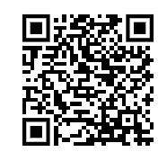
Six behaviour management tips for teachers | Academy |  |  |  |  | 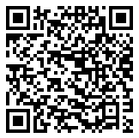
School design, impacts on learning, clever classrooms, Peter Barrett, cleverclassroomsdesign.co.uk |  |  |  |  | 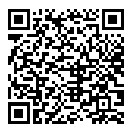
Center for instructional and behavioural research in schools- CIBRS |  |  |  |  | 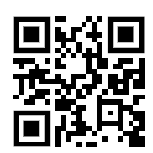
Effective behaviour supports in schools | E4L (evidenceforlearning.org.au)

The issue of increasing disruption in Australian school classrooms – Parliament of Australia (aph.gov.au) |  |  |  |  | 