
Fact sheet 4

Interpersonal Courage
Excellent educational leaders with a courageous disposition are motivated to take risks and overcome their fears to achieve the educational goals to which they are internally committed.
This disposition is manifest in excellent leaders’ commitment to their students and their willingness to challenge school and team norms, cultures and practices that prevent improved student learning and wellbeing.
Interpersonal courage means putting student relationships before adult relationships. Courageous leaders walk towards rather than run away from meetings and conversations which they fear may bring conflict and discomfort. It is also seen in their willingness to risk failure when they tackle problems others may have avoided or given up on.
Excellent leaders have the levels of personal courage necessary to have the conversations that are required to ensure the student outcomes to which they are committed. Leading improvement, which is arguably the most difficult part of an educational leadership role, also requires courage because ambitious improvement goals are unlikely to be met without challenging and improving the features of classrooms, schools and wider systems that have prevented goal achievement.
As leaders become more skilled in speaking in direct and respectful ways, they perceive such conversations as less risky and, therefore, as requiring less courage. Excellent leaders have the levels of personal courage necessary to have the conversations that are required to ensure the student outcomes to which they are committed.

Exploring together
Explore the scenarios below. Discuss together how interpersonal courage is represented in these scenarios. What would be the outcome if the disposition of was not activated?

A team leader’s commitment to excellence and equity
A team leader is committed to the educational goal of improving the attendance and achievement of indigenous students. The leader may require courage in reaching out to families from different cultures that includes overcoming their fear of being culturally inappropriate. They may also need courage to challenge negative stereotypes held by some of their peers. This demonstrates their courage to risk adult relationships in the interest of students.

A teacher leader stives for teamwork
Teachers are increasingly expected to plan and teach in teams, yet many find it difficult to raise issues they see as affecting the quality of their teamwork. A team leader notices that some colleagues don’t share the lesson planning as initially agreed and has also noticed a particular team member is using many of their plans and not contributing their own. The team leader at decides to speak to the member about it because they value the educational goal of teamwork and collective accountability. The team leader has a conversation with the colleague, despite their anxiety about upsetting someone they work closely with every day. This demonstrates the leader’s courage to overcomes fear and take a risk.

A principal tackles school data
A principal thinks about how to talk to the staff about the latest NAPLAN results. The results show minimal improvement, and the principal decides to share their feelings and co-construct a plan with the teaching staff, with the educational goal to refine the teaching and learning approaches to ensure students are receiving the quality education they deserve.
The principal fears the staff may be demoralised by the results and decides to first give them an opportunity to say how they feel and to listen carefully and avoid any blame. By doing this, the principal is overcoming their fear of what they will say by deciding to listen before they speak. In the meeting the principal proposes a collaborative inquiry into the reasons for the results, to avoid starting another round of professional learning without understanding why the previous rounds have not had the expected impact.

Practice reflection
- Do you consider yourself a courageous leader? What makes you think so? What has happened as a result of your courage?
- What conditions enabled you to be courageous in one situation but not in the another?
- What supports/ tools could help you be more courageous?
- What supports/tools could you use to lead others be more courageous?

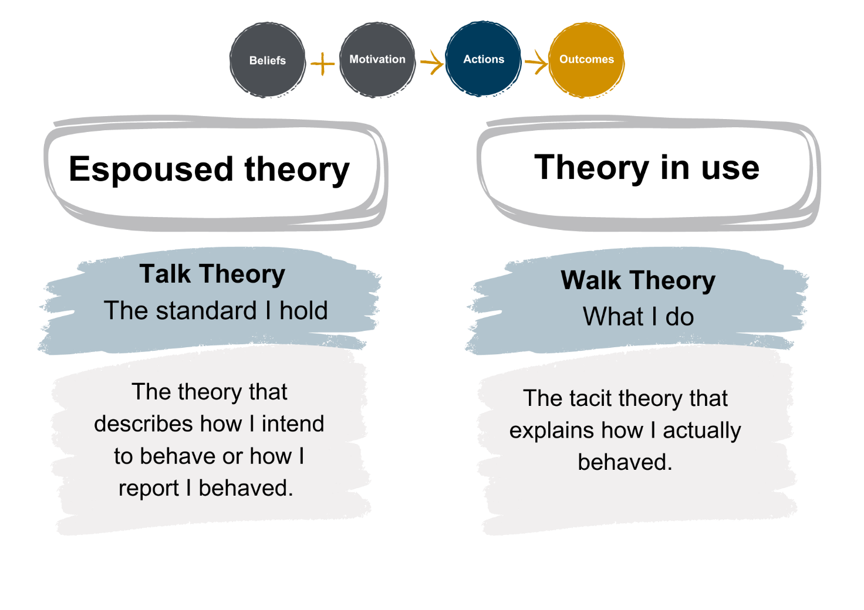
Skill building
Figure 1:
A theory of action

The purpose of this activity is to support you to plan for and practice being more courageous with a trusted colleague and receive feedback on your attempt. The open brainstorming and discussion provide an opportunity for each individual to explore alternative approaches and test their theories about how to be more courageous.
- Think about a situation where you are going to require interpersonal courage.
- Think about your “theory of action” around the situation. Write down the beliefs and motives (purpose and outcome you want from the conversation) you have about the situation and the conversation you will need to have to address it.
- Outline the actions you plan to undertake to reach the outcome. What and how might you say or act.
- Share your thoughts with a colleague and invite them to review your theory and provide feedback on your words or acts of courage.
- Role play the conversation you need to have around this issue with you colleague.
- Reflect on how the conversation went in respect of your ability to demonstrate interpersonal courage.

Robinson, V. (2018). Reduce change to increase improvement. Thousand Oaks, CA: Corwin.
Robinson, V. M. J., Sinnema, C. E. L., & Le Fevre, D. (2014). From persuasion to learning: An intervention to improve leaders’ response to disagreement. Leadership and Policy in Schools, 13(3), 260-296.

