### A yellow line drawing of hands shaking Description automatically generatedFact sheet 3

# Capability: Building relational trust

Excellent educational leaders need to be able to build a culture of trust to enable the collaborative work of complex problem solving, which is difficult and complex work. The challenge of improvement can then be experienced as shared, well supported, and competently led. Strong capability in building trust encourages a culture of justifiable risk taking, robust dialogue, collective responsibility and reciprocal accountability.

The relational capability required to lead improvement is that of building trust while doing the hard work of solving challenging problems. Leaders frequently experience a dilemma between maintaining adult relationships and tackling challenging problems, such as those involved in ensuring excellence in teaching and learning.

There is compelling evidence the level of trust between the members of a school community makes an important difference to the way they work together and to the social and academic progress of students. In schools with higher levels of trust, teachers experience a stronger sense of professional community and are more willing to innovate and take risks. In addition, students in high trust schools make more academic and social progress than students in otherwise similar but low trust school.[1], [2]

Relational trust can be defined as a type of relationship in which there is a willingness to accept risk and vulnerability because the other person is judged as being respectful, as having personal regard for others, as acting with integrity, and as competent in their role (Bryk & Schneider, 2002) (See Fig. 1).

Figure 1 – A model of relational trust, Bryk & Schneider, 2003 1

Leader’s build trust by consistently demonstrating:

* respect for others
* personal regard for others
* acting with integrity, and
* 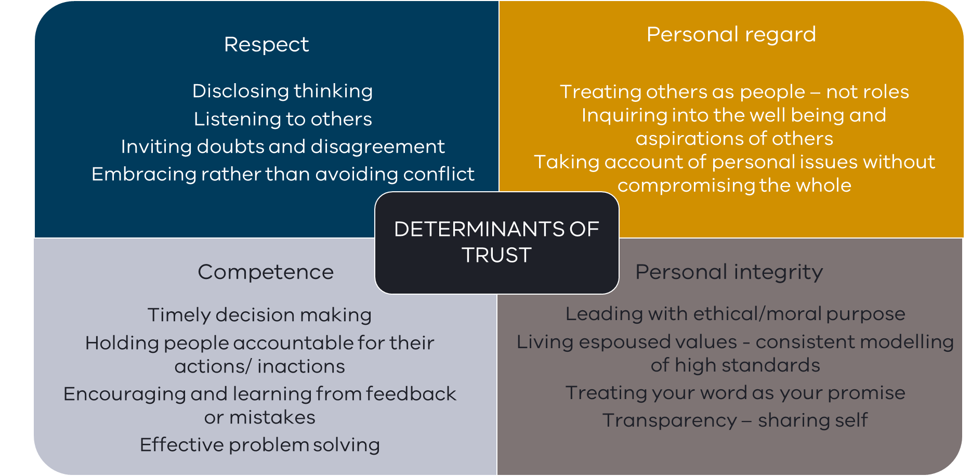role-related competence.

Figure 2 – Determinants of trust, based on the work of Bryk & Schneider, 2002

The four determinants suggest trust is built through the skilful integration of factors to strengthen relationships (being respectful and having integrity) while progressing the tasks important to the achievement of organisational goals (role-related competence).

Trust is not something to be established before tasks can be tackled - rather trust is built while doing the work with integrity and in respectful and competent ways.

### Practice reflection

Consider the model of relational trust based on the work of Bryk & Schneider below.

1. What are the deliberate actions you take to demonstrate how you:
   1. respect others
   2. have personal regard for others
   3. act with integrity
   4. are competent in your role?
2. How do you facilitate and respond to opinions which are different to your own?
3. What opportunities are there in your school for staff to provide you or the leadership team with feedback? If received, how do you act on it?
4. Who is someone that you really trust, what is it that makes them trustworthy?
5. Who is someone you do not trust, what is it that makes them untrustworthy?
6. Thinking about your answers, is there anything you think you can do to be more trustworthy?

1. Bryk, A. S., & Schneider, B. L. (2003). Trust in schools: A core resource for school reform. *Educational Leadership, 60*(6), 40; Bryk, A. S. (2010). Organizing schools for improvement. *Phi Delta Kappan, 91*(7), 23-30.
2. Goddard, R. D., Salloum, S. J., & Berebitsky, D. (2009). Trust as a mediator of the relationships between poverty, racial composition, and academic achievement: Evidence from Michigan's public elementary schools. Educational Administration Quarterly, 45(2), 292-311.  