### Fact sheet 2

# Capability: Solving complex problems

Excellent leaders who are strong in the capability of complex problem-solving tend to work collaboratively, systematically and iteratively through the five stages of complex problem solving (see Fig. 1). Excellence in problem-solving is key to improvement when the school and classroom routines that constitute business-as-usual have not produced the desired outcomes. Systematic inquiry is needed into why an approach has not worked well enough and into what might work better. A systematic approach is particularly important when tackling problems of teaching and learning that have previously proved unsolvable.

It is important to make the distinction between complex and less complex problems (see table 1) because only the former require the complex problem-solving capability described here. **Complex problems are problems which cannot be solved by current routines; or have unintended negative consequences from current routines.** Problems which are new or have resisted prior attempts to solve them, are complex because there is considerable uncertainty about the path to a solution.

Solving and resolving problems is the process of school improvement. It involves identifying a gap between what is happening now and what is desired, identifying and testing school-based reasons for the gap and then finding solution strategies that match the explanations and are likely to be effective in reducing the gap.

The stages of complex problem solving is a collaborative process because it is typically the job of leaders to lead the problem-solving process rather than complete the work on their own. The combined efforts of many people are required to solve school improvement problems. This collaboration does not prevent a leader from engaging in part or all of this process on their own when appropriate.

|  |  |  |
| --- | --- | --- |
|  | Technical Problems | Complex Problems |
| Problem | * Clearly defined problem, relatively easy to identify * Diagnose by looking at the parts | * Difficult to identify with contested perspectives * Need to see the relationships between the parts and the whole. |
| Solution | * Predictable, known solutions * Clear cause and effect * Known unknowns | * No predictable known solution or ‘fix’ * Multiple possible causes that need to be addressed holistically * Unknown unknowns |
| Learning & change | * Known solutions or can be learned * Action is relatively quick * Incremental improvement | * Generate new ways of thinking, acting and experimentation * Longer state of uncertainty |
| Approach | * Linear diagnosis of problem to action | * Driven by inquiry: Iterative process of observing – interpreting – acting – evaluating. |

Most problems in schools can be categorised into two broad types - technical and complex.

Table 1 – Technical and Complex problem features

### A screenshot of a video game Description automatically generatedCollaborative Complex Problem Solving

Figure 1 – The 5 stages of collaborative, complex problem solving

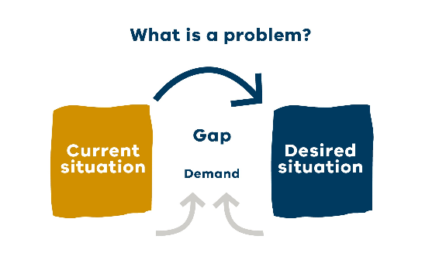**Stage 1: Problem identification**The first step in complex, collaborative problem solving is to test whether there is sufficient agreement that outcomes for particular students are less than satisfactory. A problem can be simply defined as a gap between the current situation and a desired situation.

**Stage 2: Problem causes**The next step is to generate and test causal hypotheses through a planned inquiry process, before suggesting or selecting solution strategies. There is considerable evidence that leaders who are under pressure move straight from problem identification to problem solutions, omitting discussion of causes and of solution requirements.[1]

**Stage 3: Solution requirements**It is important to establish a set of criteria against which to evaluate proposed solution strategies. By making these criteria explicit, effective solutions that address the causes of the problem and meet other practical criteria, like available time and money, are more likely to be crafted. If this stage is undertaken well, the complexity of the problem is addressed by making explicit the tensions and interactions between the various solution requirements.

**Stage 4: Problem solutions**Agreement is reached on the strategies that sufficiently satisfy the set of solution requirements, and are implemented through a progressively revised action plan.

**Stage 5: Problem outcomes**Throughout enactment, feedback about the quality and consistency of implementation, as well as about the impact of the solution strategies on student outcomes, is sought and considered by all involved.

### Practice reflection

Consider the model in light of your own practice and use the reflection questions below to help you think more deeply about how you approach complex problems.

1. Look at the five-stage model for complex problem solving. How is it similar/different to how you tackle problem solving in your school? Can you see the FISO improvement cycle in this model? How is it similar or different?
2. How do you identify practices that are not working and gain agreement on the need for improvement?
3. How thoroughly do you inquire into the likely causes of problems before seeking solutions?
4. Do you ensure agreement about the requirements for a good solution before coming up with actual solutions? How do you allocate responsibility and accountability for implementing and monitoring action plans?

1. Mintrop, R., & Zumpe, E. (2019). Solving real-life problems of practice and education leaders’ school improvement mind-set. *American Journal of Education, 125*(3), 295-344; Robinson, V., Meyer, F., Le Fevre, D., & Sinnema, C. E. L. (2020). The quality of leaders' problem-solving conversations: Truth seeking or truth claiming? *Leadership and Policy in Schools, 20*(4), 650-671.