Bite-size professional learning for school leaders

The Victorian Academy of Teaching and Leadership in partnership with Professor Lea Waters AM, PhD

Video and activity 2: Undoing stress in a positive way
Preparation
Estimated duration for this professional learning session: 55 minutes
Introduction and settling in: 5 minutes
Video: 6 minutes
Activity 1: 40 minutes
Equipment needed:
- This worksheet
- The BEU brainstorming sheet printed in A3 size (1 page per team of 4-6)
- Markers
Learning Intention
Understand the stress response and resting state
Reflect on the importance of Brief Emotional Uplifts (BEUs) in stress recovery
Identify regular transitions that happen during your day
Generate ways to create BEU during the transitions in your day
Show the video (6 minutes)
Summary of the video
Professor Barbara Fredrickson from North Carolina University is the world leader on the science of positive emotions. She says that that negative emotions are loud and grab but positive emotions are quiet so they can slip by without us noticing. Her research spans more than 25 years and consistently shows that positive emotions boost our mental health and bolster our resilience. Research experiments in her lab at North Carolina University showed that having a brief positive moment immediately following a stressful experience assists the body to recover from stress and return to its resting state faster. Brief Emotional Uplifts are the small moments that happen in your day that lift your mood. They can naturally and you can help them happen intentionally.

Doctor Adam Frazer, Australian psychologist, formed the idea of the Third Space which he defined as the transitional gaps in our day when we move from one role or task to the next. Identifying your transitional gaps and then intentionally using the third space as a time for BEUs, will help you recover from stress.

Activity 1
Step 1: On your own, identify as many transitions as you can think of that happen in a regular workday for you (8 minutes)
Time or geographical Transitions  e.g., walking from your car to the office | Role Transitions  e.g., from teacher of students to colleague with peers | Task transitions  e.g., from answering emails to working on reports

Step 2: In your team, discuss your answers with your colleagues to see if there are any transitions you need to add to the table above (7 minutes)
Step 3: As a team, brainstorm as many BEUs that can be used in the third space. The BEUs can be naturally available (i.e., already there without you having to do anything) or they can be moments that you intentionally create. The BEUs can be solitary (i.e., by yourself) or social (i.e., interacting with others). (20 minutes)
Note: you can record your individual answers in the box below; the team answers will written on the A3 handout provided by your facilitator.
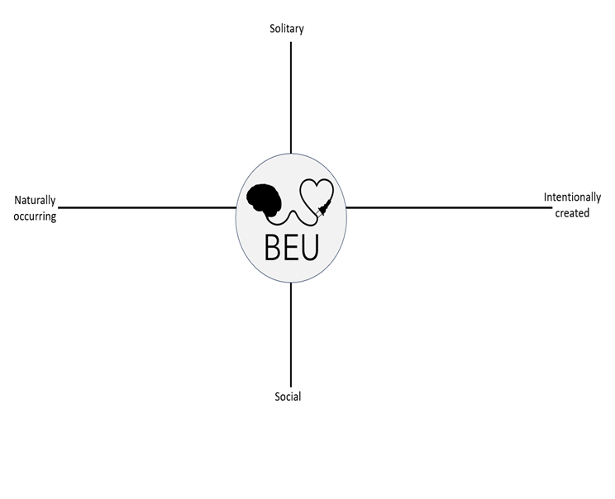
Step 4: On your own, choose 1 BEU each for 3 ‘transitional gaps’ that happen in your day. Try to choose a transitional gap for each of the three broad categories. For example, ‘walking from one meeting to another’ in the Time and Geography Transition Category (5 minutes)

Transitional Gap | BEU

Additional steps: After a few weeks you can go back to your table and your brainstormed list to choose 3 new transitional gaps and 3 new BEUs in order to keep this wellbeing strategy going.

Extra reading
Book
Fraser, A. (2021). The Third Space: Using Life's Little Transitions to find Balance and Happiness. Penguin Press. ISBN: 9781761043420
Academic journal articles
Fredrickson, B. L., Mancuso, R. A., Branigan, C., & Tugade, M. M. (2000). The undoing effect of positive emotions. Motivation and emotion, 24, 237-258.
Fredrickson, B. L. (2000). Why positive emotions matter in organizations: Lessons from the broaden-and-build model. The Psychologist-Manager Journal, 4(2), 131.
YouTube clip
https://www.youtube.com/watch?v=E2rdMjnhAgM

