Bite-size professional learning for school leaders

The Victorian Academy of Teaching and Leadership in partnership with Professor Lea Waters AM, PhD

Video and activity 3: Positive emotions, problem solving and priming
Preparation
Estimated time for this professional learning session: 1 hour 5 minutes
(Note: you can spread this PL session over 2 sessions)
Introduction and settling in: 5 minutes.
Video: 7 minutes
Activity 1: 20 minutes
Activity 2: 30 minutes
Equipment needed:
- This worksheet x 1 per person
- Butcher paper of flip chart paper in case teams want to record their answers on bigger paper for the activities
Learning Intention
Understand the link between emotions and problem solving, decision making and learning.
Reflect on the current aspects of school (both explicit and priming) that generate positive emotions.
Generate and design ideas and actions for ways to bolster positive emotions by changing the priming cues at school.
Show the video (7 minutes)
Summary of the video
Problem solving and decision making are more effective when we are in a positive emotional state. Psychology experiments show us that positive emotions change our brain chemistry in ways that help us to think more clearly, see the bigger picture, consider alternative perspectives, and develop creative solutions to complex challenges.

There are many ways to increase positive emotions in staff and students at school. Most of know about the role of culture, school values, leadership practices, extra-curricular activities, school belonging, and teacher practices on emotions. These are some of the elements that leaders and teachers explicitly cultivate to boost student (and staff) wellbeing. But what about the implicit aspects of the school that shape our emotions? For example, the school landscape, built environment, artifacts, and language are shaping our emotions every day, through the psychological process of priming.
Priming is the phenomenon by which exposure to one cue or experience influences how we respond to a subsequent experience. The external cues surrounding us at school serve to activate the brain’s automatic filtering process, which, in turn, determine where we direct our attention and shape the following thoughts and emotions we have. If we walk into school and see students laughing or are greeted by a smiling colleague, these moments shape how we interpret the next round of experiences we’ll have that morning.
Priming is happening all the time, whether we know or not. It’s typically an unconscious process but we can make it more intentional. Priming can get us ready to notice certain things and to feel and act in certain ways. Positive priming is the strategy of using positive cues and experiences to increases the chances of a people having positive emotions which in turn, increases our brains capacity to make decisions, solve problems and learn effectively.

Team activity 1
Positive Emotions not only make us feel good, they also create valuable outcomes for us by changing the way we think. Over time, frequently having positive emotions builds up valuable capacities and resources (see the table below).
Step 1: Read through the table below. In final column 4, jot down examples of how each emotion is currently fostered at your school and in column 5, suggest new ways to further increasing this positive emotion.
Note: you can generate the column 5 ideas on butcher/flip chart paper if you want a bigger ‘canvas’ (than this worksheet)

Emotion | The capacities, opportunities, and resources that this emotion fosters | How this emotion is fostered in your school
Joy | Inspires us to be playful and get involved which our increases our capacity for experiential learning.
Gratitude | Creates an urge to connect with others that builds up our pro-social capacities.
Contentment | Helps us step back and see the bigger picture giving us the opportunity to expand our view of self and the world .
Interest | Urges us to explore and find out more, thus building up the resource of knowledge.
Hope | Pulls us into the future where we plan for better things. It builds the resource of optimism .
Pride | Gives us the capacity for confidence and the internal resource of self-worth.
Amusement | Brings us levity and joviality, it gives us the opportunity to see things differently and, shared amusement in social situations bonds us with others, thus building our social resource.
Inspiration | Motivates us to achieve bigger things and strive for personal growth
Awe | Reminds us of life’s grander scale, it builds our capacity to appreciate beauty and complexity

Team activity 2
Step 1:
Looking at the areas below discuss and record the emotions you think are possibly being primed. Describe the cue and what you think it primes. For example, beanbags in a student common room are a cue that might prime emotions such as connection and relaxation. The smell of coffee and cake in the staff room for a colleague’s birthday might prompt happiness and pleasure. What do you think are the priming messages created from the notices on the staffroom noticeboard? What are the likely emotions being cued by your school entry, hallways and corridors? What emotions are being primed by the teacher as students come into class? And so on…

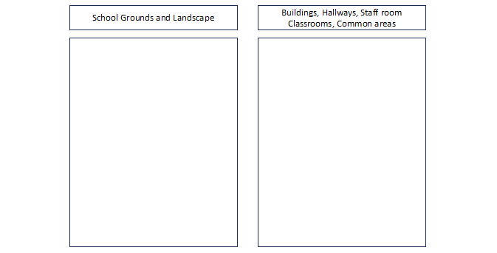
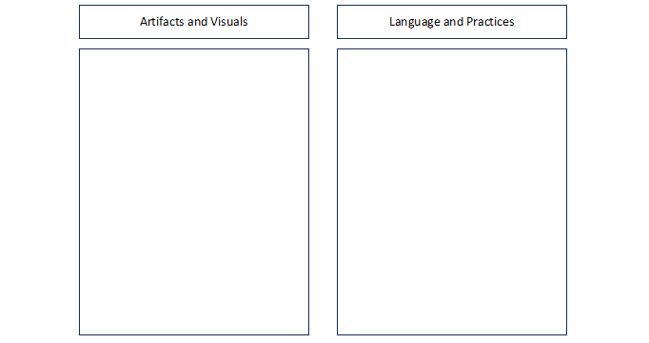

Add other priming elements here:
__________________________________________________________________________________________________________________________________________________________________________________________________________________________________________________________________________________________________________________________________________________________________________________________________________________________________________________________________

Step 2:
Based on your analysis on Step 1, decide on 2 small changes you can make at school to prime more positive emotions

Change 1:
What will be changed______________________________________________________
What emotions are you hoping to shape______________________________________

Change 2:
What will be changed______________________________________________________
What emotions are you hoping to shape______________________________________

Extra reading
Book
Frederickson, B. (2009). Positivity: Top Notch Research reveals the 3 to 1 ratio that will change your life. Harmony Publishers. ISBN 978030739374TOP-NOTCH RESEARCH REVEALS THE 3-TO-1 RATIO THAT WILL CHANGE YOUR LIFE By Barbara Fredrickson
Academic journal articles
Fredrickson, B. L., & Branigan, C. (2005). Positive emotions broaden the scope of attention and thought-action repertoires. Cognition and Emotion, 19(3), 313–332. https://doi.org/10.1080/0269993044100023

Villavicencio, F. T., & Bernardo, A. B. (2016). Beyond math anxiety: Positive emotions predict mathematics achievement, self-regulation, and self-efficacy. The Asia-Pacific Education Researcher, 25, 415-422.

Wexler, B., Iseli, M., Leon, S. et al. (2016). Cognitive Priming and Cognitive Training: Immediate and Far Transfer to Academic Skills in Children. Scientific Reports, 6, 32859 https://doi.org/10.1038/srep32859

YouTube clip
Barbara Fredrickson: Positive Emotions Open Our Mind - YouTube

