


Wellbeing Capstone

with Genos

Revisit, refresh and connect

© State of Victoria (Department of Education and Training) 2020
Revisit, refresh and connect is provided under a Creative Commons Attribution 4.0 International licence. You are free to re-use the work under that licence, on the condition that you credit the State of Victoria (Department of Education and Training), indicate if changes were made and comply with the other licence terms, see: Creative Commons Attribution 4.0 International
The licence does not apply to:
- any images, photographs, trademarks or branding, including the Victorian Government logo and the DET logo; and
- content supplied by third parties.
- The content of this workbook was supplied by Genos International who hereby provide permission to all staff within the Department of Education and Training, to use the content in Department of Education and Training activities.
Copyright queries may be directed to copyright@edumail.vic.gov.au


Revisit, refresh, connect

Throughout 2020 the Department of Education and Training (Department) partnered with Genos International to deliver a collection of interactive webinars designed to help maintain wellbeing and connection between colleagues and communities. The series of well-being webinars, including recordings and corresponding workbooks can be found on the Genos website.
This 1-hour capstone webinar brings together the content that resonated most with participants and explores how best to carry forward the learnings into the 2021 context.
We start by revisiting the notion of stretch. Of stretching yourself to go that little bit further in terms of enhancing your own well-being. What might it mean to you to be two, three, four or five per cent better at managing your own mood and emotions over the holiday period and into 2021? To this end we revisit different Thinking, Physical, Relationship and Environmental strategies for maintaining and enhancing psychological well-being.
Continuing with the notion of stretch we then invite you to explore how you could go that little bit further in terms of being a positive influence on others. We revisit our relationship circles exercise and invite you to think about people in your life you’d like to have a more positive influence on over the holiday period and into 2021. We will revisit different strategies to help us be more present and connected in our relationships and how to help others facing challenging situations.
There are three different sources of learning we hope you draw from in the webinar:
- content
- discussion
- participant led learning.

We invite you to contribute to the chat box and let colleagues know about some of the things you’ve been doing to help maintain your well-being during the year. Post your contributions to “All panellists and attendees”

Proactive well-being strategies

These are often grouped into the four areas shown below. The most effective strategies are those that become a way of life, and which are applied proactively in your day-to-day activities, rather than something done reactively.

 | Thinking strategies – one of the most effective ways of managing emotions is to think about emotions from different perspectives. For example, exploring the benefits and consequences of them, causes of them and different ways of responding to them.
 | Physiological strategies – our physiology can have an impact on the way we feel and manage stress. Changing our physiology through exercise, diet, sleep and other activities can help us manage emotions more effectively and build our resilience.
 | Relationship strategies – connecting and sharing with others provides us with the opportunity to express and explore our feelings and get someone else’s input or support for them. Expressing how we feel can help us manage our emotions.
 | Environment strategies – factors external to us can impact how we feel at work, such as deadlines, our workload, and the environment we are working in. Changing our conditions and/or our working environment can help improve the way we feel as well as our resilience.

Proactive well-being strategies

 | Thinking  - Creating boundaries  - Reducing how often you tune into news/social media  - Gratitude reflections  - Diarising ‘think’ and reflection time  - Perspective taking, and generally balancing what you watch, listen to and read

Notes: What’s a new thinking strategy you could adopt over the coming weeks?


 | Physical  - Sleeping better  - Drinking less alcohol and caffeine  - Improve your diet by eating more nutritious whole foods  - Exercise – something most days  - Mindfulness meditation (Smiling Mind)

Notes: What’s a new physical strategy you could adopt over the coming weeks?

Proactive well-being strategies
 | Relationships  - Relationship improvement (goal setting and actions)  - Staying connected with people, structure regular check in times  - Getting involved in network groups, conferences and industry events  - Leaning into conflict/difficult conversations

Notes: What’s a new relationship strategy you could adopt over the coming weeks?

 | Environmental  - Burning scents, playing music  - Structuring email and call times  - Doing something you love in the outdoors  - Doing things that move you emotionally  - Working on your work area

Notes: What’s an environmental strategy you could adopt over the coming weeks?

Stretch action plan - self

What things are you already doing that you could do more of to boost your well-being over the holiday period and into 2021?

Looking back over your list of NEW things you could start doing, what will you do to boost your well-being over the holiday period and into 2021?

In the spirit of continuous improvement, when do you plan to revisit what you’ve been doing, to reflect on and renew your approach?

Being a positive influence

In this next part of our session we invite you to turn your attention to improving your close relationships by engaging in this relationship circles activity. Firstly, give each circle a relevant heading that indicates the relationship (for example Partner, Friends, Colleague, Siblings, Parents, Students, Children). Then put the names of relevant people in them. Then choose someone (one person for the purpose of the activity), you’d like to focus on in the next activity. This someone should be someone you’d like to improve your relationship with over the holiday period and into 2021.

Being a positive influence

Below is a list of the things we can do to positively influence others in our day-to-day interactions.
Plan interactions and be more intentional. One way of improving our interactions and having a more positive influence on others is to plan for our interactions and be more intentional in how we set them up. Below are some of the things you can ask yourself or consider:
- What mood and emotions might the person I’m meeting with have?
- What mood and emotion is most appropriate for the interaction? Nothings worse that someone’s unbridled positivity when the mood and emotions of others is more sombre.
- What’s the best environment for this interaction (inside/outside, formal, relaxed), what might help foster connection?
- What questions could I ask?
- How am I doing to acknowledge what I’ve heard and signify my understanding?
- What interesting and relevant information could I share?

What other things can we plan for, or be more intentional about, when setting up our interactions with others? Leave a comment in the chat box and watch for others. Write down the new ideas that come from hearing the session moderators and reading your colleague’s contributions in the chat box.

Be present and demonstrate mindful listening. People feel more listened to and understood when we are present (rather than distracted) in our interactions with them. To enhance your skill at being present and demonstrating mindful listening you can practice mindfulness meditation. There are many great mindfulness apps and resources available on the web. Smiling Mind is a non-for-profit, free to use, web and app-based meditation program developed by psychologists and educations to help bring mindfulness into your life.
What else can you do to be present and demonstrate mindful listening when interacting with others?

The list below should be viewed simply as ‘thought provokers’, ideas that you might be able to apply to the relationship and person you have decided to focus on. Each idea requires further forethought and research to better define your application of it. One thing worth thinking about when coming up with ideas of your own, or building out those below to suit your context is this: research examining the effectiveness of relationship improvement strategies has shown that those who focus on improving themselves (rather than try to change the other person in the relationship), generally have greater success¹.

Strategy | Activities
Improve the quality and/or amount of time you spend together | - Identify activities of mutual interest to engage in together (e.g., cooking, listening to or playing certain music, walking in nature etc).  - Practice mindfulness mediation to help you become more present and mindful when spending time with others  - Put your phone and other distractions away when together  - Take the time to conceptualise fun or interesting new things to do together
Read books or blogs on how to improve specific aspects of relationships. | - Increase intimacy in a partner relationship https://www.psychologytoday.com/au/blog/creating-in-flow/201602/10-proven-ways-you-can-increase-intimacy  - Improve your parenting https://www.parents.com/parenting/better-parenting/advice/8-ways-to-be-a-better-parent/  - How to be a better friend https://www.lifehack.org/articles/communication/10-ways-better-friend.html
Read books or blogs or engage in courses on how to improve specific relational skills | - Increase your skill at facilitating difficult conversations https://schools.au.reachout.com/articles/how-to-have-difficult-conversations  - Improve your empathy https://andrewsobel.com/eight-ways-to-improve-your-empathy/  - Improve your communication in relationships https://positivepsychology.com/communication-in-relationships/  - Enhance your skill at facilitating interesting conversation https://coachingforleaders.com/facilitate-great-conversations/

Depending on the context of the relationship you have chosen to work on, one additional idea is to simply engage in conversation about how you could improve the relationship. For example, by simply asking “what could I do to improve our relationship”.

- Hira, S. N., & Overall, N. C. (2011). Improving intimate relationships: Targeting the partner versus changing the self. Journal of Social and Personal Relationships, 28(5), 610–633. https://doi.org/10.1177/0265407510388586

Stretch action plan - others

What new things are you going to do to improve your relationship with the person you identified in the circles activity?

In the spirit of continuous improvement, when do you plan to revisit your circles and work on improving your relationship with someone else you noted down?

Positive influence blog resources:
7 Simple ways to be a positive influence: https://www.trainingzone.co.uk/community/blogs/christinapd/7-simple-ways-to-be-a-positive-influence-as-a-leader
The importance of good influences https://www.psychologytoday.com/us/blog/happiness-in-world/201004/the-importance-good-influences
How The Way You 'Show Up' Affects Your Influence: https://www.forbes.com/sites/rodgerdeanduncan/2019/08/13/how-the-way-you-show-up-affects-your-influence/#2a609e7b2892

Helping others respond to challenging situations

There is a lot of great research on how we can best help others respond to challenging situations. Some of this research is noted here. Some of it can seems counter intuitive which is another reason why it’s worth reflecting on.
- When helping others it’s important to manage your own emotions and demonstrate appropriate emotions for the context of your discussion. It is important not be try and bring positivity to the conversation as messages of positivity can deny others a very real sense of struggle and can isolate them further. The Age and SMH published a good article on this recently https://www.smh.com.au/lifestyle/health-and-wellness/it-s-ok-not-to-be-ok-experts-say-it-is-time-to-ditch-toxic-positivity-20200820-p55nh9.html While there is no right way to be, you have to be fit for context, generally calm and caring, Avoid words and phrases like “everything will be fine”, “look on the bright side…” and so on.

- Listen and coach as much as possible and provide advice only where necessary or invited to give it. This is particularly important when you have been in similar situations and overcame them. In such circumstances we can be quick to jump in offering advice on how to overcome something and appear particularly confident in our suggested approach. It is harder to empathise with people if we’ve been in their shoes. Known as the empathy gap phenomenon, research has shown that: 1) people generally have difficulty accurately recalling just how difficult a past challenging experience was; and 2) people who have previously overcome a challenging experience know that they were able to do so which makes them particularly confident in their understanding of ‘how to’. When people feel calm and confident they often have trouble appreciating the ‘hot’ affective states of others

- Generally, plan and be intentional. It only takes a few minutes of consideration to demonstrably improve your approach. Ask yourself like:

  - What environment is the best for this conversation?
  - What emotion do I want to project and how will I do that?
  - What words and phrases should I avoid?
  - What’s my purpose for this interaction?
  - What’s my intention for this interaction?

The E.A.R. coaching model for helping others

The model presented below is a cognitive reframing model that can be used as a guide for a coaching/mentoring conversation to help someone identify the best possible response to make to a challenging situation.

It’s also worth thinking about:
- Setting up an environment that facilitates connection
- To use purpose, and vulnerability to foster trust and relatedness
- Use open questions and mindful listening to hear and grasp how the person is thinking and feeling
- Acknowledge what you’ve heard to signify your understanding

Recommended reading
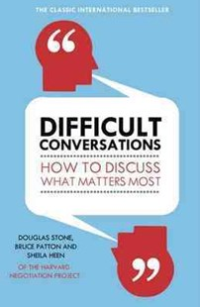

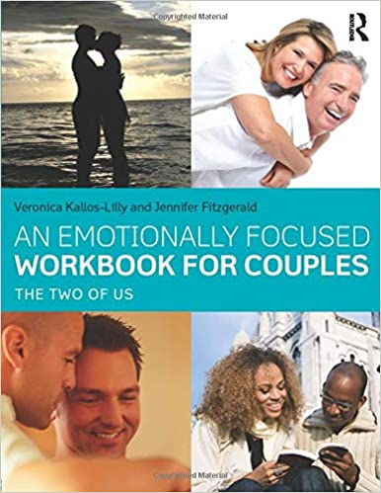

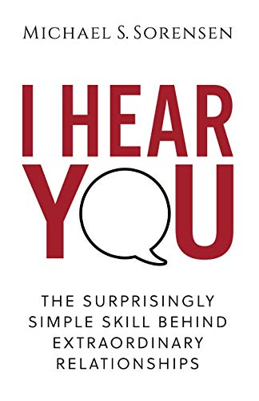
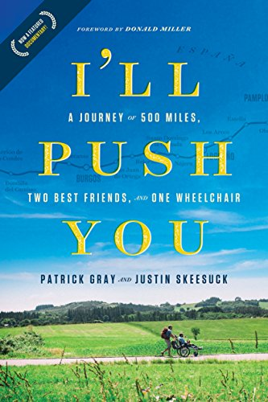

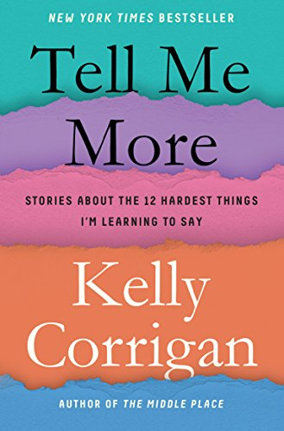






Game changing for business. Life changing for people
About Genos
Genos is a global team of change-makers using emotional intelligence to enhance how people connect, communicate and collaborate at work. Transforming these essential people skills at work also makes a difference to peoples’ relationships outside of the workplace. People become better parents, partners, siblings and friends. That’s why Genos calls their work game changing for business. Life changing for people.
Genos is a leading, global provider that delivers on their mission with transformational content, great digital technology, exceptional customer service, passionate partners and clients who want to lead their industries.

